Absolutely. Let’s do a beginner-friendly AWS S3 Bucket Mini Project step by step, including what each step means and the commands you can use.
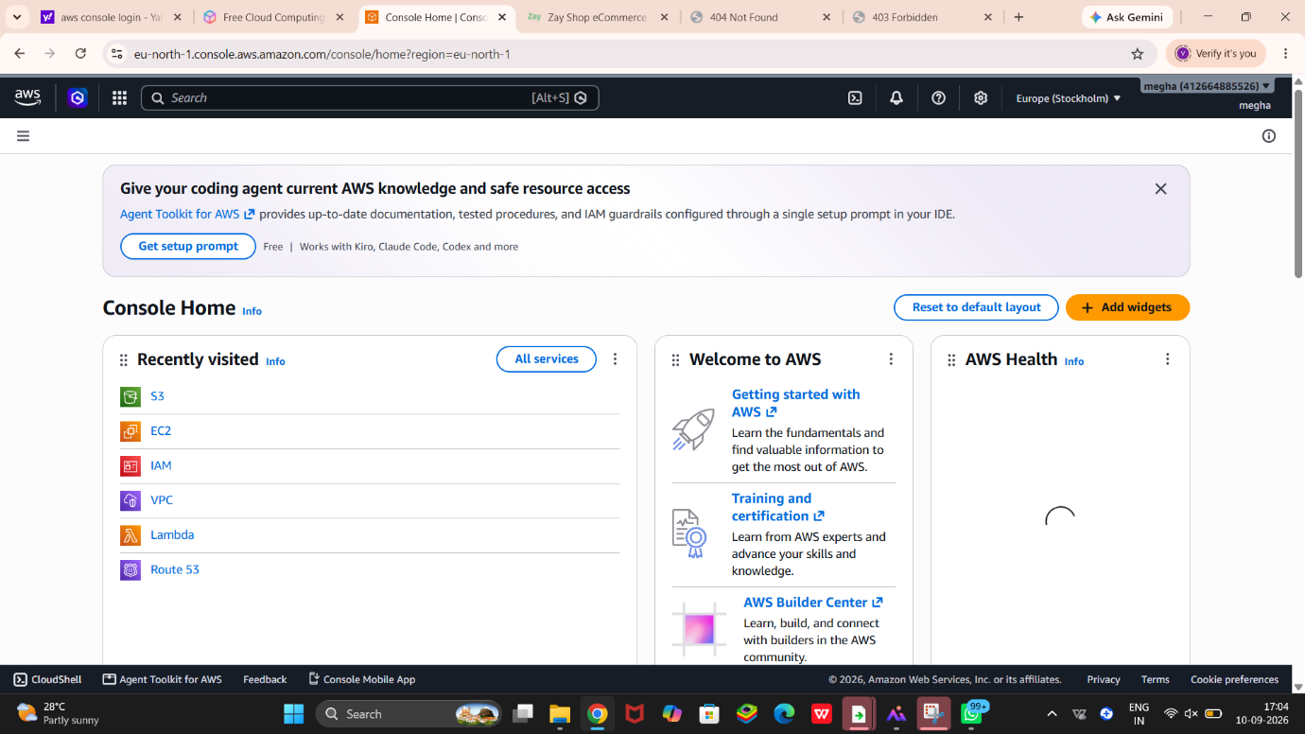
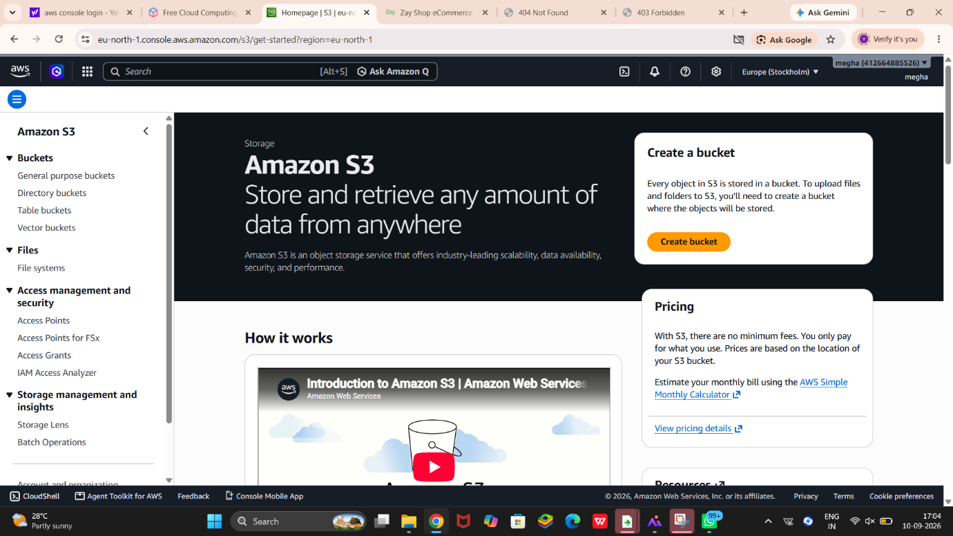
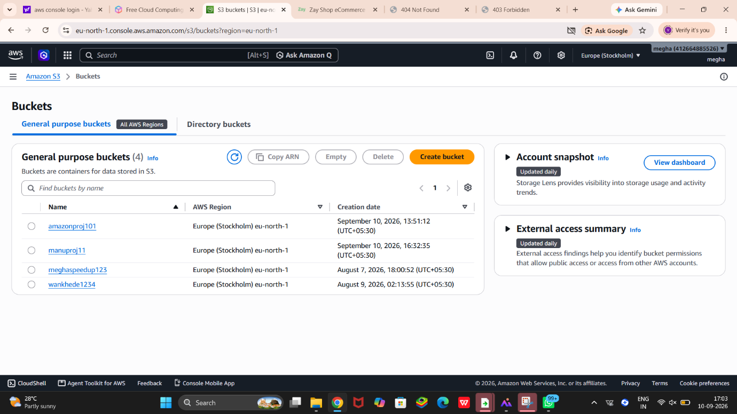
☁️ AWS S3 Bucket Mini Project
🎯 Project goal
We will create a simple static website using Amazon S3.
Flow:
Your PC → S3 Bucket → Upload Website Files → Configure Static Website Hosting → Access Website
Step 1: Create an S3 Bucket
Open the AWS Console.
Search S3.
Click S3.
Click Create bucket.
Give your bucket a unique name, for example:
megha-s3-mini-project-2026
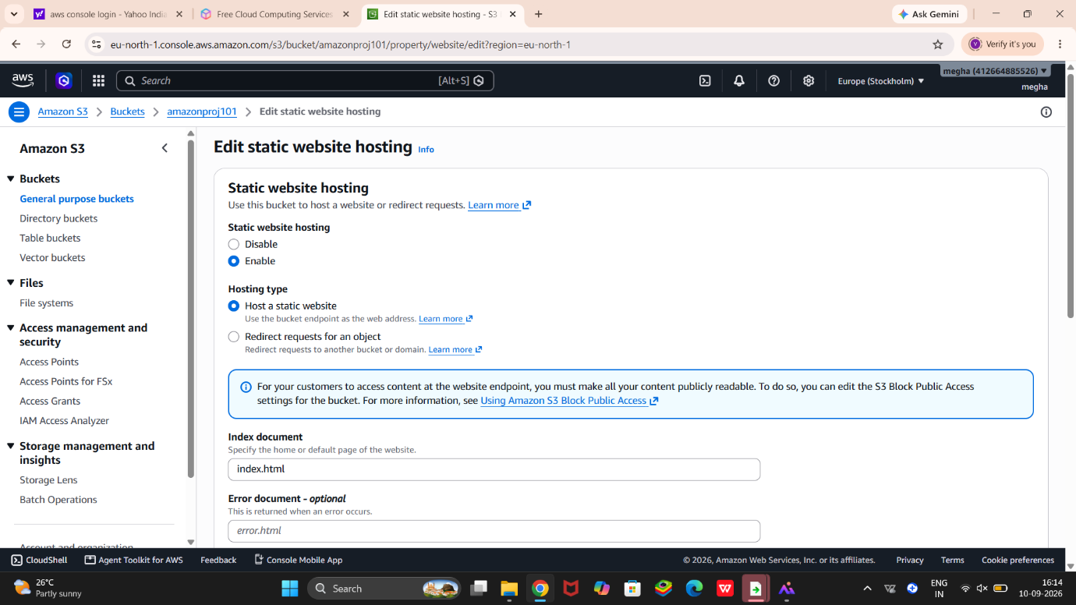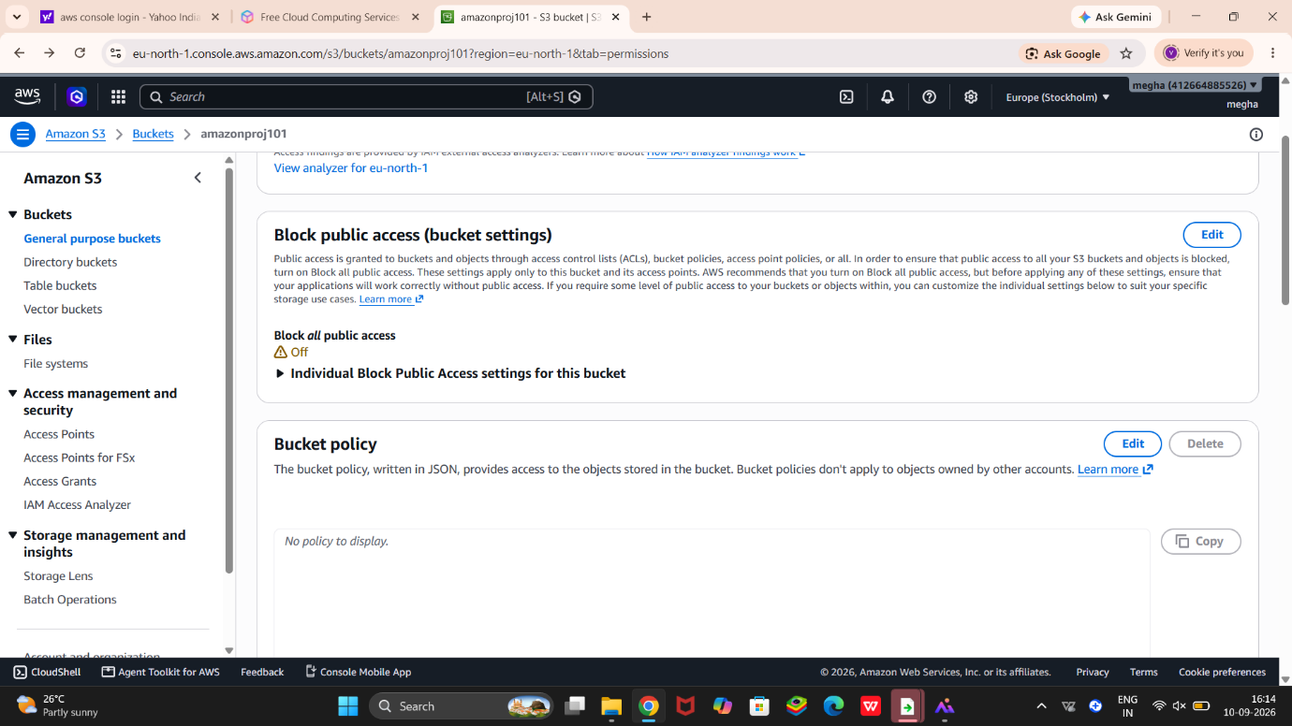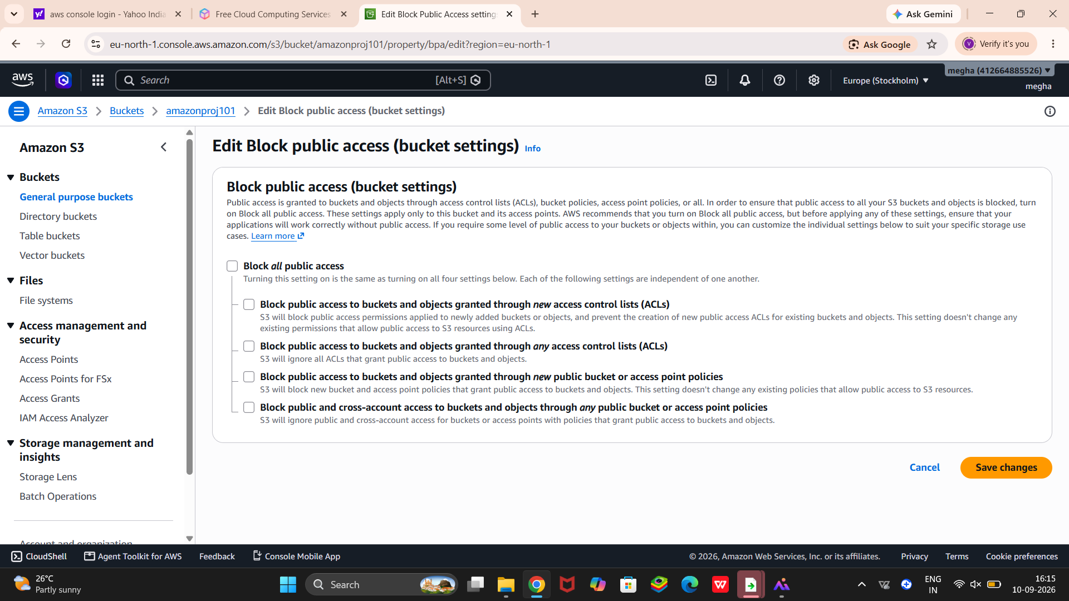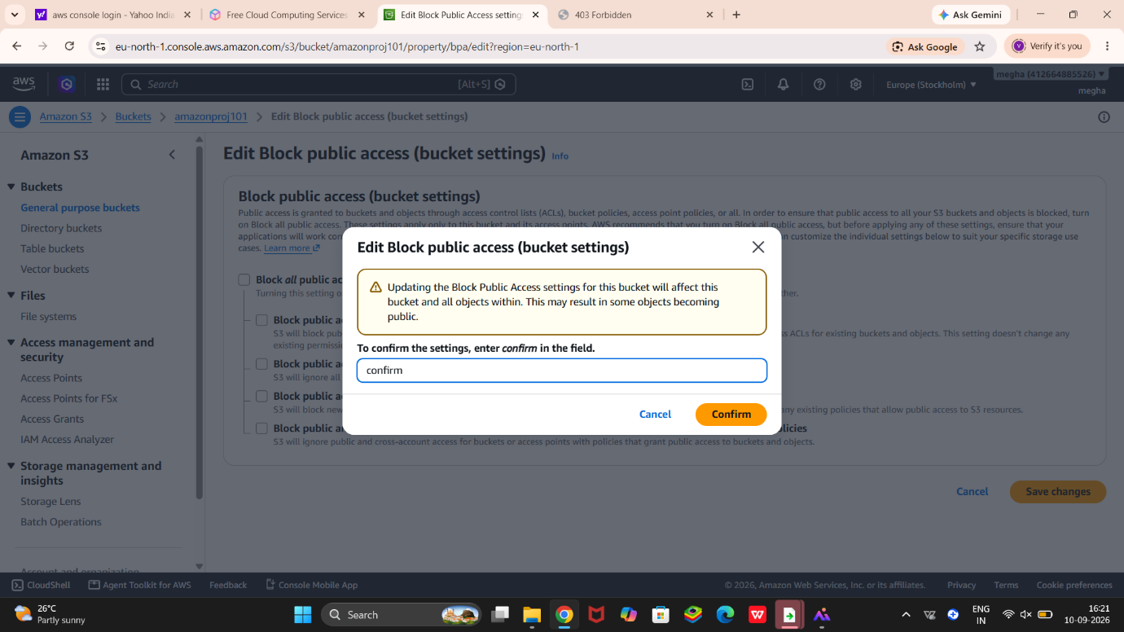
⚠️ Bucket names must be globally unique.
Select your AWS Region.
Keep Object Ownership → ACLs disabled.
For this mini project, we will eventually need public access for the website, so under Block Public Access, uncheck Block all public access.
Tick the warning checkbox.
Keep the remaining settings as default.
Click Create bucket.
What happened?
You created cloud storage where you can store files such as:
index.html
style.css
images/
Step 2: Open Your Bucket
Click your newly created bucket.
You should see:
Objects | Properties | Permissions | Metrics
The Objects section is where your files will be stored.
Step 3: Create Your Website File
On your computer, create a file called:
index.html
For a simple test, put this inside:
HTML
<!DOCTYPE html>
<html>
<head>
<title>My S3 Website</title>
</head>
<body>
<h1>Welcome to My S3 Mini Project</h1>
<p>My first website hosted on AWS S3!</p>
</body>
</html>
Save it as:
index.html
Step 4: Upload index.html to S3
Go back to your bucket.
Click Upload.
Click Add files.
Select index.html.
Click Upload.
Click Close.
Now your bucket contains:
index.html
Step 5: Enable Static Website Hosting
Go to:
Bucket → Properties
Scroll down until you find:
Static website hosting
Click Edit.
Select:
Enable
Choose:
Hosting type: Host a static website
For:
Index document
enter:
index.html
Then click:
Save changes
Step 6: Allow Public Access
Now go to:
Permissions
Find:
Block public access
Click Edit.
Disable:
Block all public access
Confirm the warning and click:
Save changes
Why?
Normally S3 protects your files from public access.
For this particular website project, we want a browser to access index.html, so we need to allow public access.
Step 7: Add Bucket Policy
Still under Permissions, find:
Bucket policy
Click Edit.
You'll need to add a policy that allows people to read the website objects.
Use this structure, replacing the bucket name with your actual bucket name:
{
"Version": "2012-10-17",
"Statement": [
{
"Sid": "PublicReadGetObject",
"Effect": "Allow",
"Principal": "*",
"Action": "s3:GetObject",
"Resource": "arn:aws:s3:::YOUR-BUCKET-NAME/*"
}
]
}
For example, if your bucket is:
megha-s3-mini-project-2026
then:
"Resource": "arn:aws:s3:::megha-s3-mini-project-2026/*"
Click:
Save changes
Step 8: Get Your Website URL
Go back to:
Properties → Static website hosting
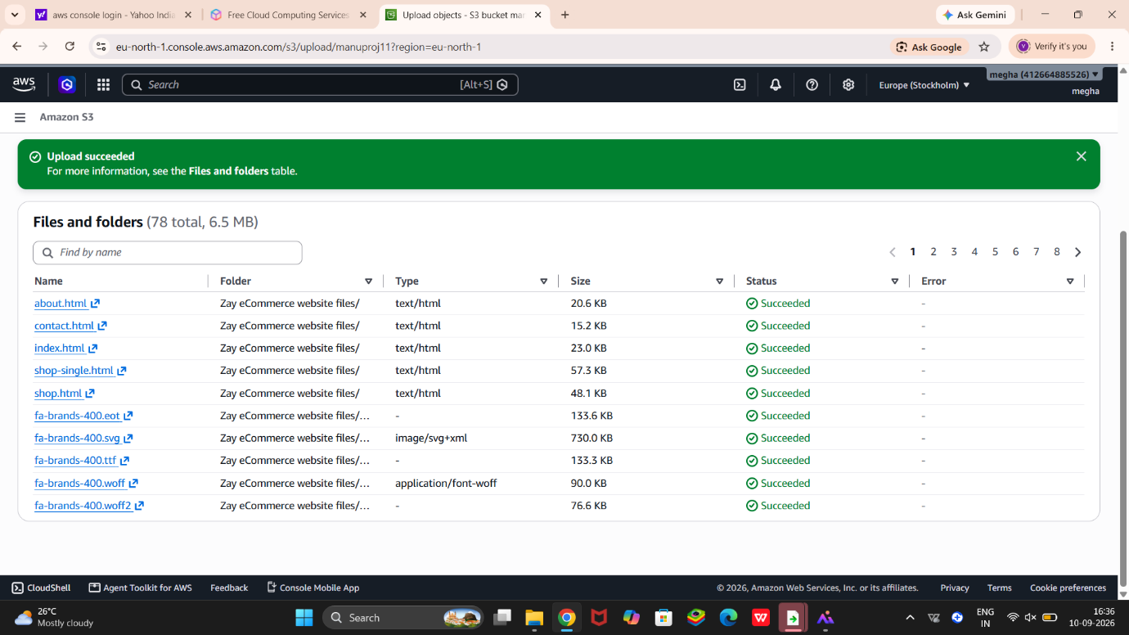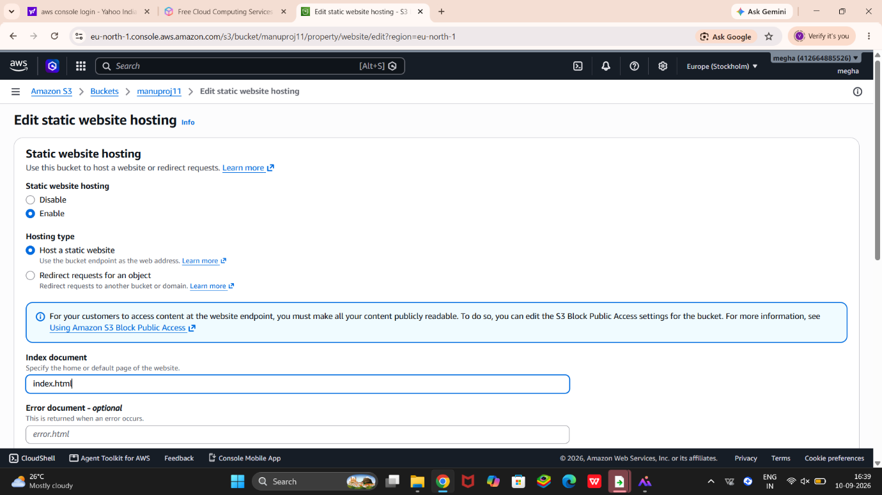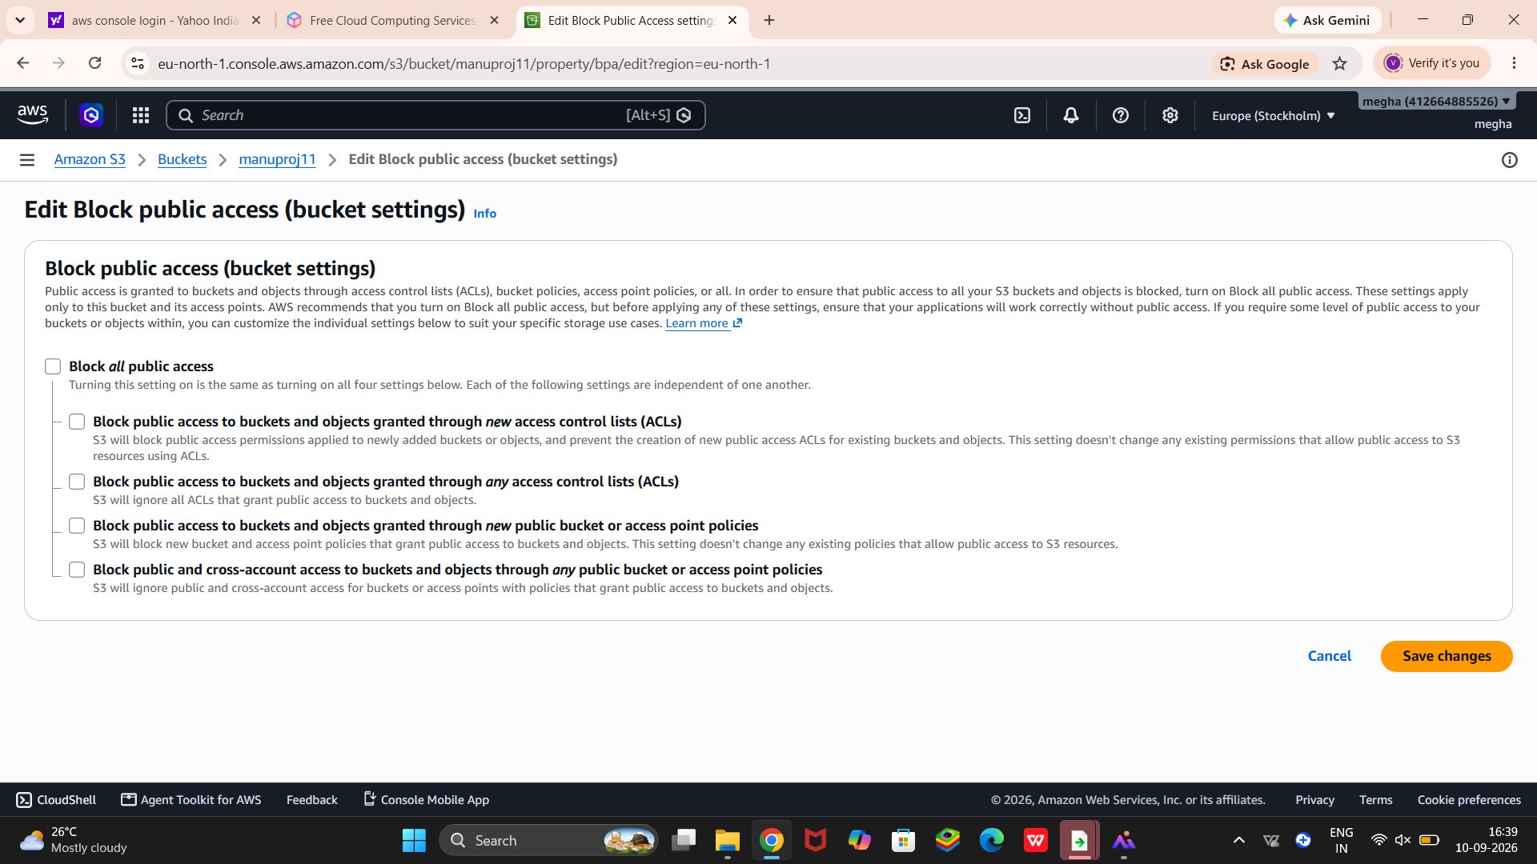
You should see:
Bucket website endpoint
Click the URL.
Your website should open in the browser 🎉
You should see:
Welcome to My S3 Mini Project
My first website hosted on AWS S3!
Step 9: Add CSS
Now let's make the project look better.
Create another file:
style.css
Example:
body {
font-family: Arial;
text-align: center;
margin-top: 100px;
}

h1 {
font-size: 40px;
}
Upload style.css into the same S3 bucket.
Then modify your index.html:
HTML
<!DOCTYPE html>
<html>
<head>
<title>My S3 Website</title>
<link rel="stylesheet" href="style.css">
</head>
<body>
<h1>Welcome to My S3 Mini Project</h1>
<p>My first website hosted on AWS S3!</p>
</body>
</html>
Upload the updated index.html.
Refresh your website.
🧠 What you learned
AWS Concept
What you did
S3
Created cloud storage
Bucket
Created storage container
Object
Uploaded files
Bucket Policy
Allowed public read access
Static Website Hosting
Hosted HTML website
Index Document
Set index.html as homepage
Public Access
Allowed browser access
CSS
Styled your website
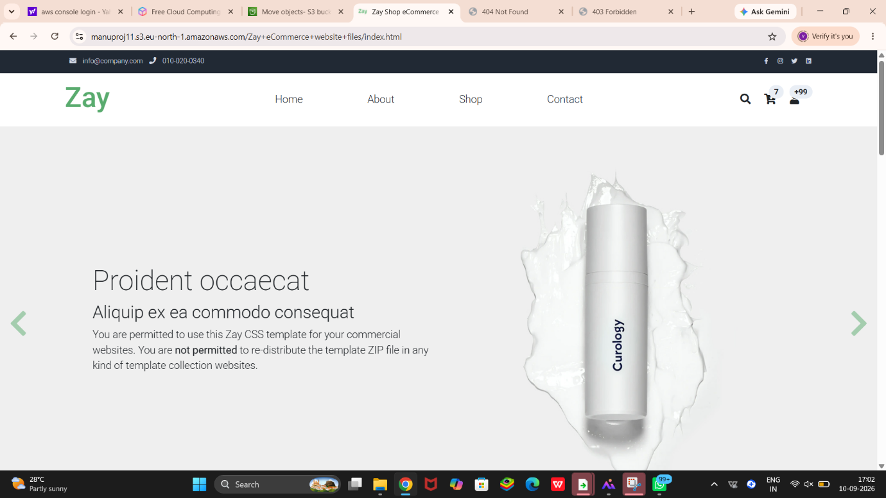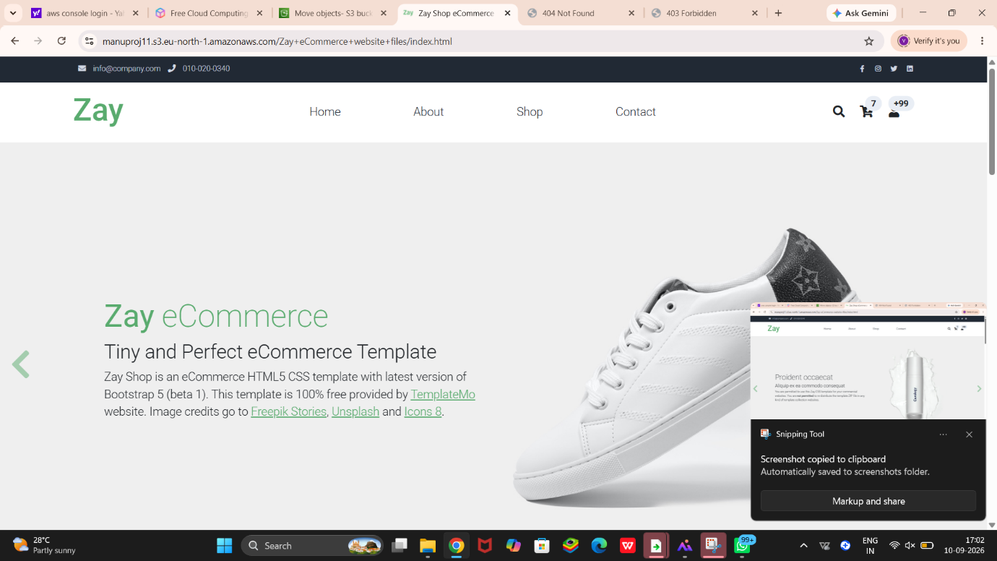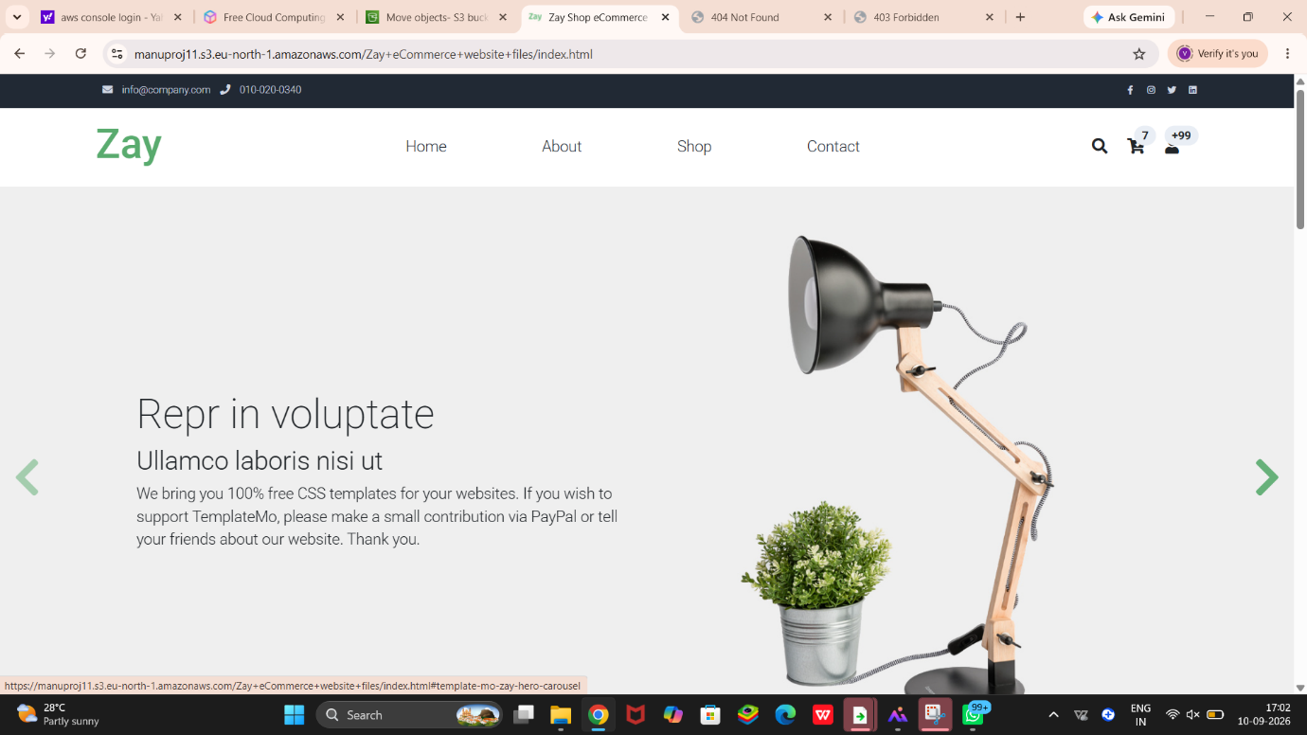
🔥 Mini-project architecture
INTERNET
│
▼
┌───────────┐
│ S3 │
│ BUCKET │
└─────┬─────┘
│
┌─────────┴─────────┐
│ │
index.html style.css
│ │
└─────────┬─────────┘
▼
🌐 WEB BROWSER
│
▼
YOUR WEBSITE
💼 How to explain this in an interview
“I created an Amazon S3 bucket, uploaded HTML and CSS files, enabled static website hosting, configured the index document, and applied a bucket policy to allow public read access. The website can then be accessed through the S3 website endpoint.”
Important: This project is excellent for learning S3, but for a real production website you generally wouldn't make an S3 bucket publicly readable like this; you'd normally use a more secure architecture such as CloudFront + S3 with public access blocked.

